­­­­ WHAT IS MACHINE LEARNING

Machine learning is the part of broader field of AI this field is concerned with the capability of machines to perform activities using human like intelligence.

Techniques in machine learning

->SUPERVISED LEARNING=every training sample from the dataset has a corresponding label or output value associated with it. As a result algorithm learn to predict output.

-> UNSUOERVISED LEARNING=there is no label for training data. A machine learning algorithm tries the underlying patterns or distribution that govern the data.

-> REINFORCEMNT LEARNING=the algorithm figures out which action to take in a situation to maximize the reward on the way to reaching a specific goal. This is completely different approach than supervised and unsupervised learning.

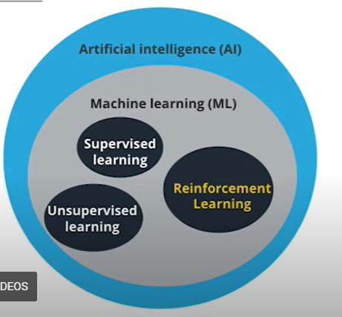

HOW MACHINE LEARNING IS DIFFERENT  
🡪Traditional Method : In traditional problem-solving with software, a person analyzes a problem and engineers a solution in code to solve that problem. For many real-world problems, this process can be laborious (or even impossible) because a correct solution would need to take a vast number of edge cases into consideration.

Imagine, for example, the challenging task of writing a program that can detect if a cat is present in an image. Solving this in the traditional way would require careful attention to details like varying lighting conditions, different types of cats, and various poses a cat might be in.

🡪Machine Learning: In machine learning, the problem solver abstracts away part of their solution as a flexible component called a model, and uses a special program called a model training algorithm to adjust that model to real-world data. The result is a trained model which can be used to predict outcomes that are not part of the dataset used to train it.

In a way, machine learning automates some of the statistical reasoning and pattern-matching the problem solver would traditionally do.

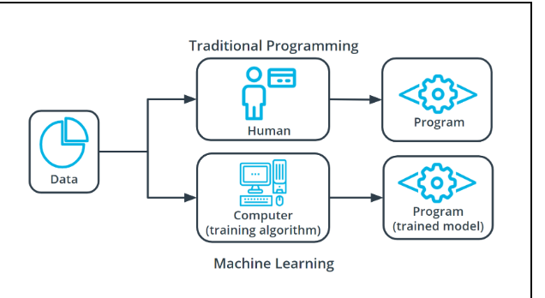

COMPONENTS OF MCHINE LEARNING  
machine learning has three primary component

🡪a machine learning model

🡪a machine training model

🡪a model inference model

* **MACHINE LEARNING MODEL:** it is block of code used to solve different problems. A generic program, made specific by data.
* **MODEL TRAININGALGORITHM:** it is a iterative process which involve 2 steps

1. Determine what changes need to be made
2. Make small changes to the model

* MODEL INFERENCE MODEL: using the trained model to make prediction.

we can understand this using the example of clay analogy

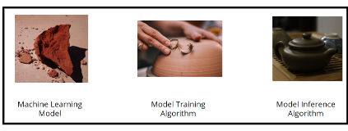

MAJOR STEPS IN MACHINE LEARNNG MODEL

